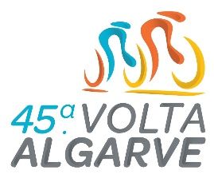

Pedido de Acreditação / Press Accreditation Request

Órgão de Comunicação Social / Firm - Publication - Agency:

_________________________________________________________________

Representante/Special representatives:

Nome/Surname and first name __________________________________________
Função/Position _____________________________________________________
Email_________________________________________________________________
Telefone/Phone Number_________________________________________________
Carteira Profissional / Press card No.(juntar fotocópia / attach photocopy) _______________________________

Carro / Car
Marca e Modelo / Make _______________________________________________
Matrícula / Registration No. ____________________________________________
Condutor / Driver(s) __________________________________________________
Carta de Condução / Licence number _____________________________________
Companhia de Seguros/Insurance Company ________________________________

Moto/Motorcycle
Marca / Make _______________________________________________________
Matrícula / Registration No. _____________________________________________
Condutor / Driver(s) __________________________________________________
Carta de Condução / Licence number _____________________________________
Licença UCI/UCI Licence number __________________________________________
Companhia de Seguros/Insurance Company ________________________________

Precisa de Rádio-Volta? / Do you need Radio-Tour receiver?

Sim/Yes Não/No

Data e Assinatura / Date + Signature

___________________________________________________________________

Enviar para/Send to: jose.gomes@fpciclismo.pt

